**Individual HW: 02**

CS51510-001, fall 2025

Purdue University Northwest

**09/19/2025**

**In-Memory Database**

|  |  |
| --- | --- |
| Name | Email |
| Kowshick Srinivasan | **Srini252@pnw.edu** |

Table of Contents

Table of Figures 4

Table of Pseudo Code 4

Abstract 5

Introduction 5

User Story 5

1.1 Acceptance criteria 5

1. Software Design 5

2. Student Class 6

1.1 Equals 7

1.2 Convert Student to String 7

1.3 Convert Boolean to string 8

2. Linked List class 8

2.1. Insert Method 9

2.2 Delete Method 9

3. Memory Database 9

3.1. Read the CSV file 10

3.2. Read method 10

3.3. File Watcher 11

3.4. Reload Method 11

3.4.1. Both file and the Linked list has not reached the end 11

3.4.2 File has reached the end and not the Linked List 12

3.4.3 Linked list has reached the end and not the File 12

3.4.4 Both file and Linked list has reached the end 12

3.5. Prepare for printing 12

3.6. Print Linked List 13

3.7. Prepare to execute 13

4. Executing the Program 14

1. Using Java 15

2. Using Python 16

5. Sample Test Cases 19

5.1. Base cases 19

5.1.1 Insert at middle 19

5.1.2 Delete from middle 20

5.1.3 Insert at end 21

5.1.4 Delete at top 22

5.2 Edge cases 23

5.2.1 Insert at top 23

5.2.2 Delete at end 24

5.2.3 No Insertion or deletion 25

5. Shutting down the Virtual environment 26

Key takeaways 27

Singly Linked List 27

Recursion 27

File IO 28

Multi Threads 28

Conclusion 28

FAQ 28

Acknowledgement 29

Bibliography 29

Appendix 30

1. Using Java 30

1.1 Student Class 30

1.2 Linked List Class 34

1.3 MemoryDatabase class 35

2.Using Python 39

2.1Student Class 39

2.2 Linked List Class 42

2.3 MemoryDatabase class 43

# Table of Figures

Figure 1-Class diagram 6

Figure 2- Compile and run the Java program 15

Figure 3- Do changes to CSV when program is running 16

Figure 4- Updated output CSV 16

Figure 5- Run the python program 17

Figure 6- Do changes in CSV and detected by program 17

Figure 7- Stop the watcher 18

Figure 8- Output reflecting the changes 18

Figure 9- Insert at middle 19

Figure 10- Output reflecting insertion in middle 20

Figure 11- Delete from middle 20

Figure 12-Output reflection deletion from middle 21

Figure 13- Insertion at the end 21

Figure 14- Output reflection insertion at the end 22

Figure 15- Delete the head 22

Figure 16- Output reflecting deletion of head 23

Figure 17- Insert a new head 23

Figure 18- Output reflecting insertion of new head 24

Figure 19- Delete the last node 24

Figure 20- Output reflecting deletion of last node 25

Figure 21- Unchanged input 25

Figure 22- Unchanged output 26

Figure 23- Shutting down Ubuntu 27

# Table of Pseudo Code

Pseudo-code 1: Student Class 7

Pseudo-code 2- Compare two objects Method 7

Pseudo-code 3- Convert to string 8

Pseudo-code 4- Node Class 8

Pseudo-code 5- Linked List Class 8

Pseudo-code 6- Insert new node 9

Pseudo-code 7- Delete a node 9

Pseudo-code 8- Memory Database class 10

Pseudo-code 9- Read from CSV 11

Pseudo-code 10- Update middle of the linked list 11

Pseudo-code 11- Update the end of linked list when EOF 12

Pseudo-code 12- Update at end of linked list when not EOF 12

Pseudo-code 13- Output in CSV 13

# Abstract

Design and implement a memory database using singly Linked List data structure, that is able to read the student data from the CSV file, adapt to any changes done in the CSV file and write it a output CSV file.

# Introduction

This document is part of Algorithms course (**51510-001**), individual **homework-2**. The goal of the document is to create a memory database using Linked list that can store student details from a CSV file, Adapt to changes that are done to the CSV file, and write the output in a new CSV file.

We first download the student dataset from the given website <https://www.kaggle.com/datasets/kellygakii/student-data-csv>. The implementation of this memory database has been done in two programming languages **JAVA** and **PYTHON**

The below document explains the User requirement, software design, Student class- which defines the attributes of a student (from CSV), Then it explains the singly Linked List class and it functionalities, leading us to the implementation of the memory database with the given constraints, finally we end the document with the results screenshot and sample test cases to prove the working of the memory database.

# User Story

I want a lightweight **in-memory** database to store **variable** number of student records, I should be able to read and store the student records from a **CSV** **file** and the database to adopt to any insertions or deletion in the CSV file **automatically** and finally I should be able to **export** the database to a CSV file.

## 1.1 Acceptance criteria

* **Recursively** read the *student-data.csv* file to the memory database
* Adapt to any changes in the CSV file
* Export the in-memory database to a CSV file
* Should be able to run in **Ubuntu** environment
* Need the solution in **Java** and **Python**
* Provide output Screen shots to prove the working

# 1. Software Design

We are given with five constraints to follow while building the memory database and there are as follows,

* Use a **Singly linked List** for the in-memory database as the size of the dataset can scale in real-time
* Follow **Recursive** functions since the user specified it
* Use **file watcher** service to observe if there is any file modification change and reload the database
* Reload **only** the changes not the entire database
* Provide **Object-oriented** solution using Java and Python

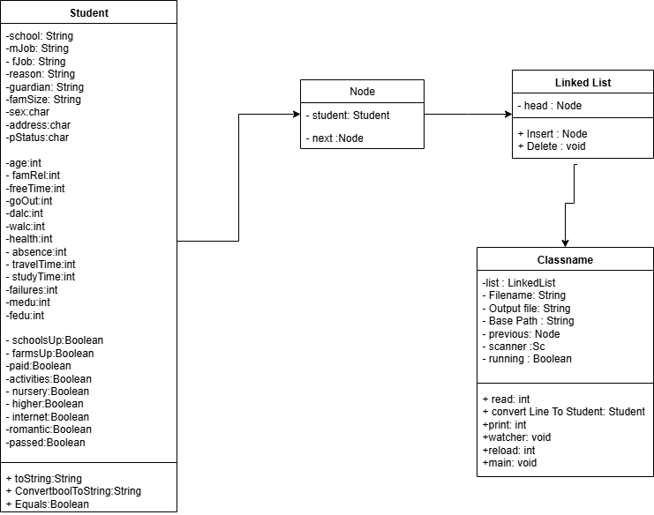

Figure -Class diagram

2. Student Class  
this is the blueprint of the student details that are supposed to be read and stored in the Linked List. From the given CSV file we can see there are 31 features to a student which included school, age, sex and paid.

Class Student

String school;

.

.

Character sex;

.

.

Integer age;

.

.

Boolean paid;

String ConvertToString (BooleanVariable)

Boolean Equals(student2)

String toString(student)

Pseudo-code : Student Class

The class also contains a constructer method to convert the read CSV row (CSV reader returns a comma separated String line) to Student object. Two student attributes/methods one to convert the Student object to comma separated String, which can be written back to the CSV file and an equals methods that checks the equality of two student objects.

Note not all the attributes of the Student class are String objects, some are of primitive data types likes char, Int and Boolean. This allocation of different data types is to improve the program efficiency by reducing the memory required by String data type.

## Equals

It is a overwritten method of the equals() method provided by the Object class. By default is compares two object’s memory location if same return equal (shallow comparison). We over write the method to compare the member variables of the two objects and say they are equal or not (deep comparison)

Boolean equals(obj)

Return school == obj.school && age == obj.age && sex =obj.sex ….. ;

Pseudo-code - Compare two objects Method

## Convert Student to String

It is a overwritten method of the toString() methods provided by the Object class. By default it converts the object to string so that it can be used to print/debug/ We overwrite the method to return the Object in a specific string format (Comma separated values)

String toString(student)

Return school +”,’+sex+”,”+”,’+age+”,”+address+……….”

Pseudo-code - Convert to string

Note we don’t need to specify the keyword this to specify to point to the class variable, since it is a member method

## Convert Boolean to string

The user understands only the way that is specified in the input, we can convert the value and store in the memory but it is important to speak the same language of the user. The user document contains “yes” “no” instead of True/False, so the output should also be in the same language.

# 2. Linked List class

This class defined a singly linked list, with a static inner class which is used to define a Node.

The inner class Node define how a Linked list node should be like, Since it is a singly Node, it contains the student data and a pointer to the next Node. It also has a constructor which initializes the Node object with the student data and always the next Node address is set to null be default.

Static inner class Node

Student student;

Node next;

Node(student)

This.student=student

This.next=null

Pseudo-code - Node Class

The outer class defined the structure of the Linked list on whole, initially the Linked list only contains the head Node and we can chain in any number of Nodes as and when needed. So the class only contains a head of type Node, Along with the function like insertion of a new node at the end of Linked List.

Pseudo-code - Linked List Class

Class LinkedList

Node head;

Static inner class Node{…}

Node insert(currentNode , student, nextNode)

Node delete(prevNode,nextNode)

## 2.1. Insert Method

This class method is used to insert a node as the head Node if List is empty or at the back of an existing Linked List; this accepts current last nod, the Student details object and the next Node (If there is no next Node it is null). It returns the updated last node, i.e. the current node.

Pseudo-code - Insert new node

Node insert(currentNode, student, nextNode)

newStudent = Node(student)

newStudent.next = nextNode

if head==null

head=newStudent

else

currentNode.next=newStudent

return newStudent

## 2.2 Delete Method

This class method is used to delete the Node. We mean delete is we unlink the node from the linked list so that the garbage collector can remove the hanging Node. This method accepts the previous node and the next node, so that the pointer of the previous node can be set to the next node, making the current node hanging.

Delete (previousNode, nextNode)

Pseudo-code - Delete a node

If previousNode = null //delete the head node

Head = nextNode

Else

previousNode.next = nextNode

# 3. Memory Database

This is the class that is responsible for creating and maintaining the memory database using the linkedList class. It has 4 member variables, LinkedList, inputFile, output file, a condion variable and a scanner object. It also has a constructor to instantiate the member variables (We use constructor based dependency injection) along with the following methods.

Class MemoryDatabase  
 LinkedList() list

String input file

String output file

Scanner sc

Boolean condition

MemoryDatabase(LinkedList list, inputFile,OutputFile,Scanner sc)

This.list =list

This.inputFile = inputfile;

This.outputFile= outputFile

This.sc =sc

This.condition = true

<Following methods>

Pseudo-code - Memory Database class

## 3.1. Read the CSV file

Firstly we convert the CSV file to a inbuilt Reader object, to facilitate successful reading of the file.

BufferedReader br = new BufferedReader(new FileReader(<Input.csv>)

We can now invoke the readline() method of the Reader class to read the row one by one. This method reads one row at a time and moves the pointer to the next line internally, so that we invoke the method again the next line of the file is read returning the entire comma separated row as a String.

Br.readLine()

We skip the header row/ Capture the header separately to use it while printing the output CSV.

We can have a dedicated method to recursively read the CSV file and add the student details at the end of the Linked List.

## 3.2. Read method

This method recursively calling readLine() method to read the Reader object until the end of file is reached and calls the linkedList.insert() method to insert a new node. Accepts the Reader object and the last node of the Linked List (Initially, Reader and head node) It return status code 0 as a completion reading the file to EOF.

The readLine() method return a comma separated String which is first split into a string array using regular exp “,” before befing converted into student class object. We again convert some String into int,char and Boolean to match with the student class data types.

Once we have the student, we call the LinkedList.insert() list to insert in the linked list, which return the last node of the Linked list.

We recursively call the read() method with the Reader object (read pointer is managed by the object itself) and the updated last nod of the Linked List.

Pseudo-code - Read from CSV

Int read(Reader,lastNode)

String row = reader.readline()

If row == null //If EOF

Return 0;

String[] line = row.split(“,”)

Student student = convertStringToStudent(line)

Node node = LinkedList.insert(lastNode,student)

Return read(Reader,node)

## 3.3. File Watcher

A separate thread that is responsible to notify if there is any modifications in the given CSV file. This monitors the file continuously until there is a keyboard interrupts to stop the watching process. When there is any change in the file it triggers a utility method to detect what and where the change happened in the CSV file and make changes to the Linked list accordingly. Accepts and return void.

## 3.4. Reload Method

This utility method recursively checks the File using the file Reader object for any changes, the check happens by comparing the file lines with the Node of the Linked list, The check can be of three type,

### 3.4.1. Both file and the Linked list has not reached the end

If there is any mismatch is the row and the corresponding Node of the linked list, then there is a flag of something is changed, The key idea to find if something is inserted or deleted is if something need to be deleted from the linked list then the next node of the linked list will be equal to the current row of the linked list or null else it is insertion operation.

Pseudo-code - Update middle of the linked list

If current.next is not null and reader is not null

If currentRow is not currentNode.student

If curentRow is equal to nextNode.student

Delete current note

Else

Insert current row in the Linked list

### 3.4.2 File has reached the end and not the Linked List

If there are extra node in the Linked list and not the file then those node needs to be deleted from the linked list

Pseudo-code - Update the end of linked list when EOF

If current.next is not null and reader is null

Delete current node

### 3.4.3 Linked list has reached the end and not the File

If there are extra rows in the File and not the linked list then those rows needs to be added at the end of the linked list.

If current.next is null and reader is not null

Pseudo-code - Update at end of linked list when not EOF

Insert current row in the Linked list

### 3.4.4 Both file and Linked list has reached the end

Both the linked list and the File is in Sync and we can safely return back to the calling function

## 3.5. Prepare for printing

Open the Output CSV file in writer mode using the in build writer object.

PrintWriter printWriter = new PrintWriter(new FileWriter(<Output.csv>);

We can now use the println() method which is part of printWriter to write our content in the newline.

Also write the header line which was read and stored separately during the read step

printWriter.prinln(header);

Now we can call the dedicated method that traverses the Linked List and print the student details in the CSV recursively.

Note print() method writes in the same line and println() write in a new line, and the printer writer class keep track of the last line written and points to the next available line.

## 3.6. Print Linked List

This method is used to traverse and print the linked list node by node recursively in the output CSV file. This method accepts the Writer object and the current Node (Initially passing the head node). And returns the completion status when reached the last node of the Linked list.

Get the student object from the current node and convert it to comma separated String. Also use the println() method of the Writer object to write the comma separated string in the CSV file. Finally check if this is the last node of the Lisnked List if yes return the completion status else recursively call the print() method with the updated currentNode.next and the writer object.

print(writer,currentNode)

Row = currentNode.student.toString()

Writer.println(row)

If currentNode.next == Null

Return 0

Return print(writer,currentNode.next)

Pseudo-code - Output in CSV

## 3.7. Prepare to execute

Get the input CSV file and the output file location from the user as input parameters

1.Instantiate the memory Database class by passing the input filename, output file name and the Linked list class object as constructor parameters

2. Open the input file using the Reader object and the output file using Writer object.

3. Read the header line before calling the read() method to recursively read the rest of file

4. Create a new thread watcherService() and load it with the watcher method

5. Start the watcher thread, which pause the current/main thread

6. Wait until the watcher thread completes and joins with the main thread

7. Print the header into the output CSV file before calling the print() to recursively print all the node of linked list to the output.csv recursively.

Step 2 to Step 7 might throw different exception including file not found, so enclose all in a try block and handle all the exception collectively using the catch block.

# 4. Executing the Program

Make sure all the source program and the required data have been downloaded an in place. The folder structure is given as follows,

Downloads

|

AlgoIndHw2-main

|

IndHw2

|

---- Java

|

----LinkedList.java

----Student.java

----MemoryDatabase.java

-----Python

|

----LinkedList.java

----Student.java

----MemoryDatabase.java

-----Data

|

----student-data.csv

Also make sure to change the student-data.csv file after starting the executions of the program, to verify the adoption of Linked List with any changes respect to the CSV file, you can **refer to one of the sample test cases below**.

## 1. Using Java

To execute,

Open terminal where we have the python programs **Downloads>AlgoIndHw2-main>IndHw2>Java**

“***javac *.java***” – this compiles the all the java files in the current directory to the .class file

“***java MemoryDatabase***” – this executes the MemoryDatabase.class file which has the main method and that is used for executing a java program, The rest two classes are dependents so those are executed when the program initializes them internally.

Note the class file name is the same as the java class name given in “*MemoryDatabase*.java”. We can also run the java file in one command “*java MemoryDatabase.java*” but it is not recommended for large scale applications. Also it is worthy to mention running the java MemoryDatabase only triggers the **main** and the Memory database class and it methods needs to be initialized inside the main method (Static and not static methods)

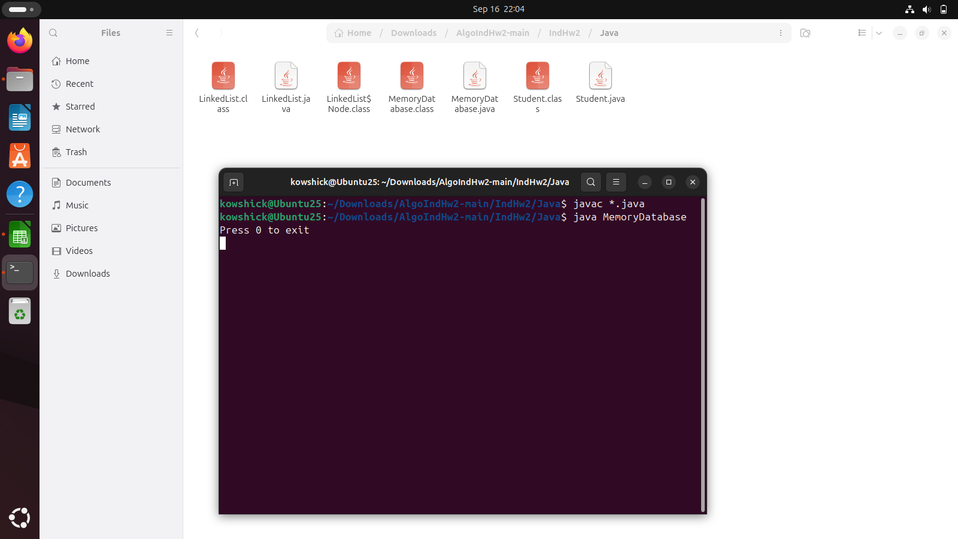

Figure - Compile and run the Java program

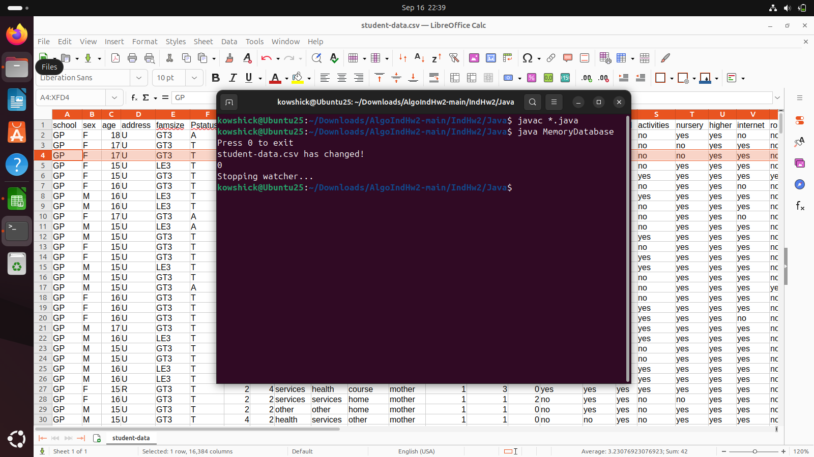

Figure - Do changes to CSV when program is running

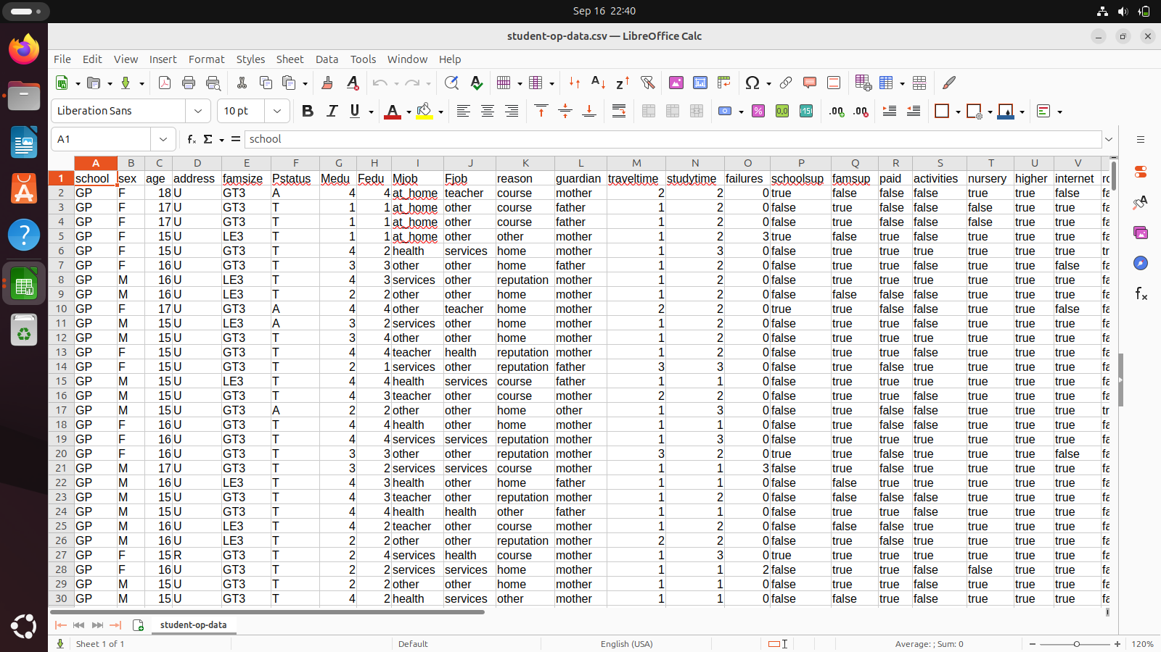

Figure - Updated output CSV

## 2. Using Python

To execute

Open terminal where we have the python programs **Downloads>AlgoIndHw2-main>IndHw2>Python**

“***python3 MemoryDatabase.py***” – command interprets and executes the code.

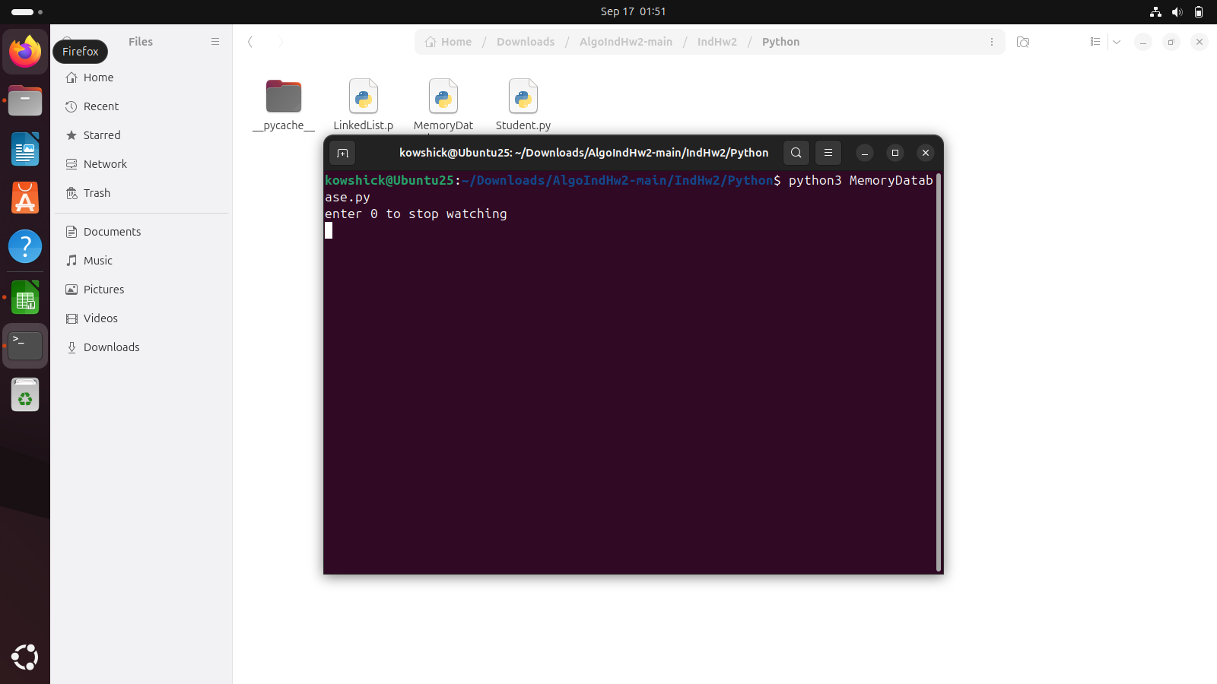

Figure - Run the python program

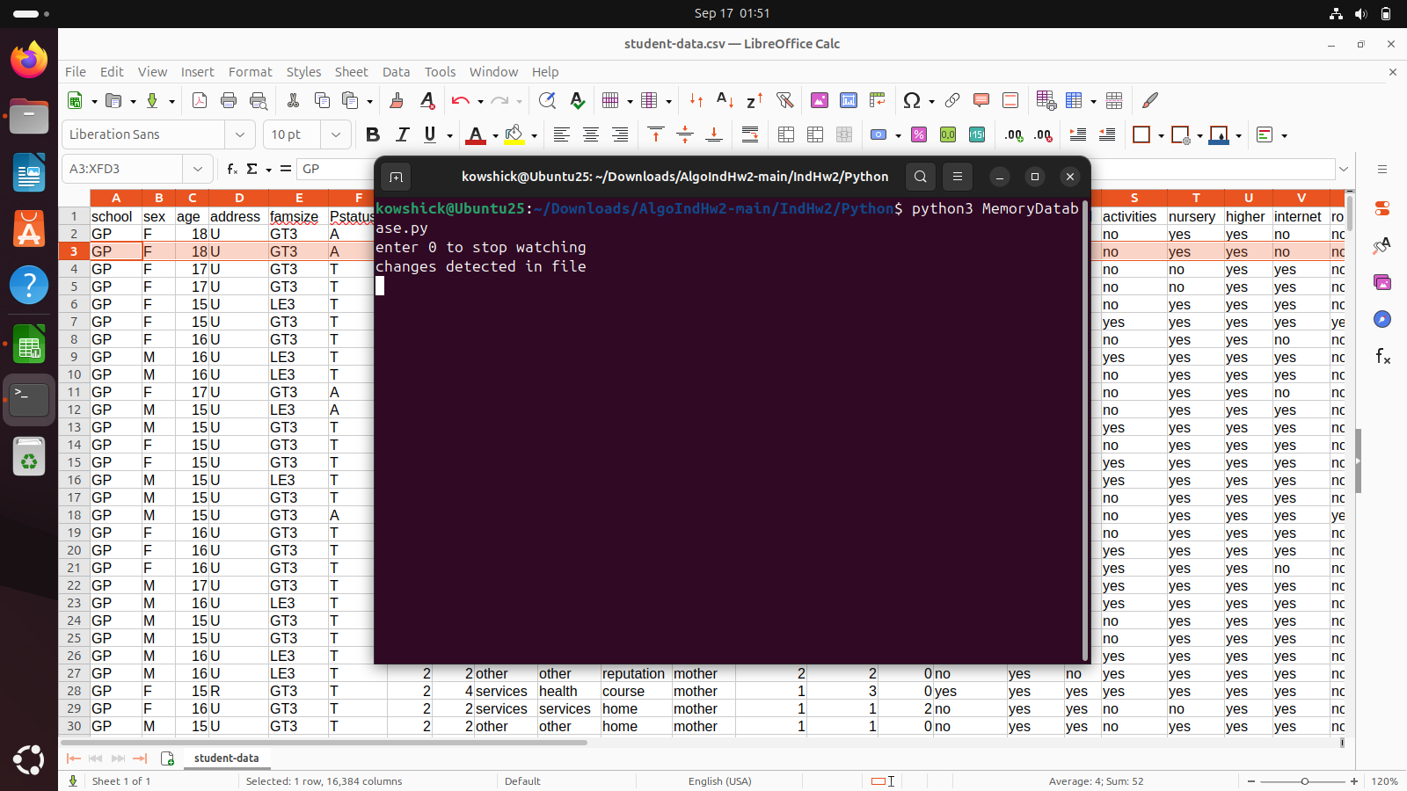

Figure - Do changes in CSV and detected by program

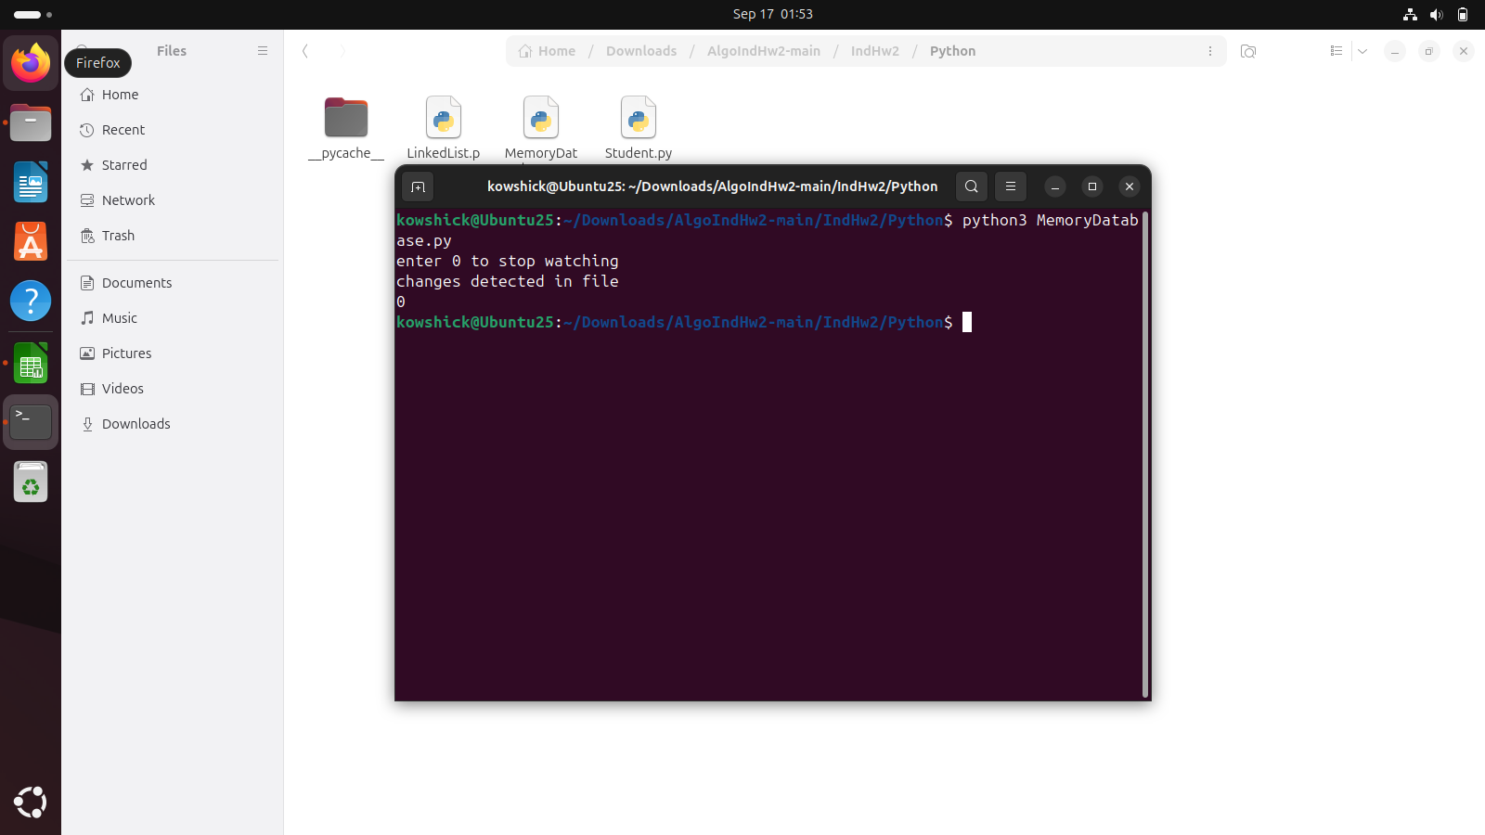

Figure - Stop the watcher

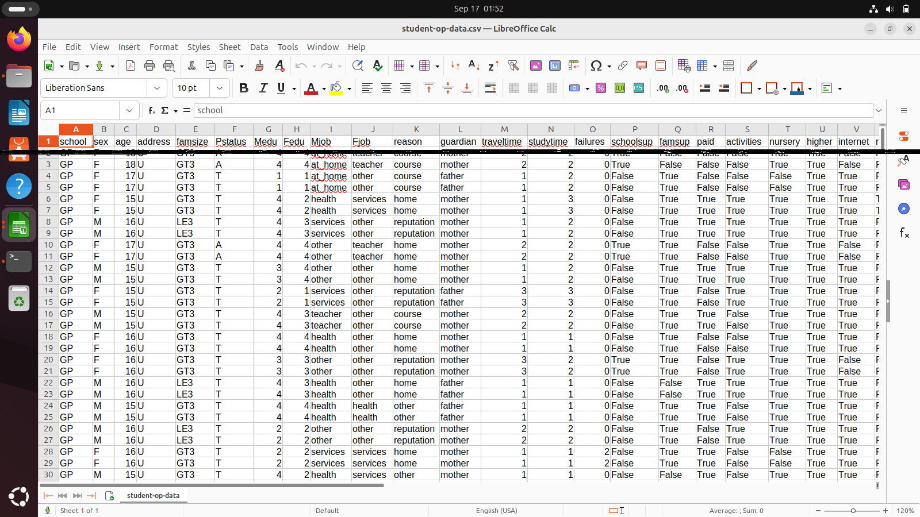

Figure - Output reflecting the changes

# 5. Sample Test Cases

## 5.1. Base cases

### 5.1.1 Insert at middle

Insert a student record somewhere in the middle of the existing CSV as shown

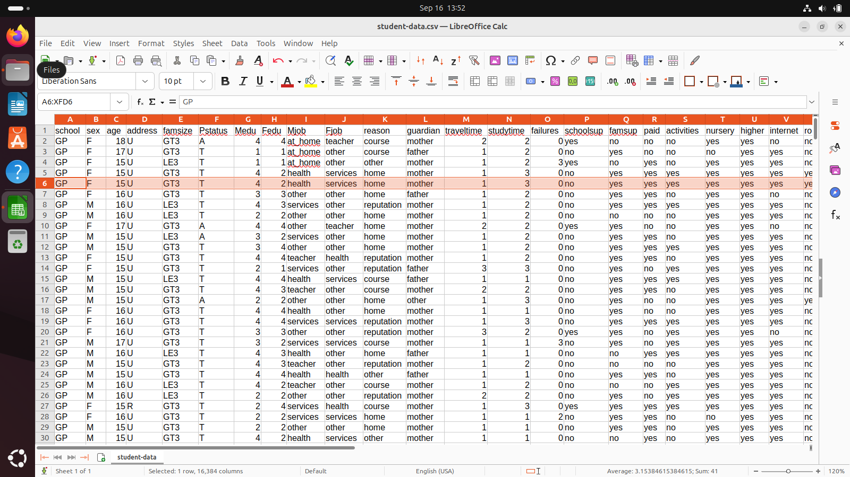

Figure - Insert at middle

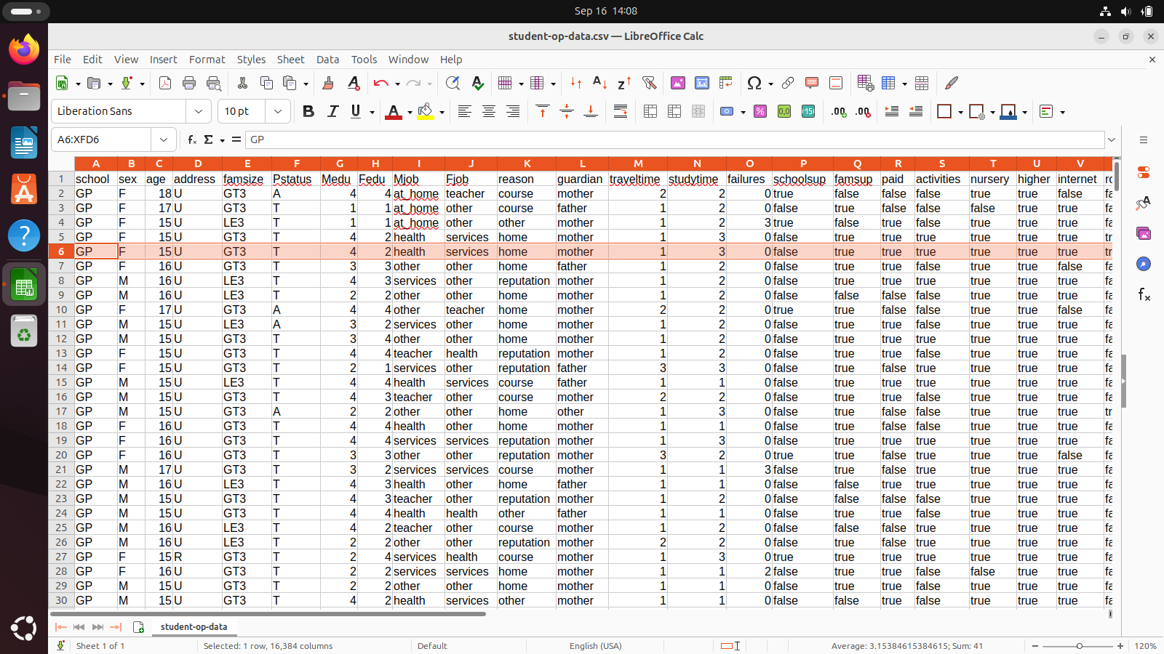

Figure - Output reflecting insertion in middle

### 5.1.2 Delete from middle

Delete a student record somewhere from the middle of the existing CSV as shown

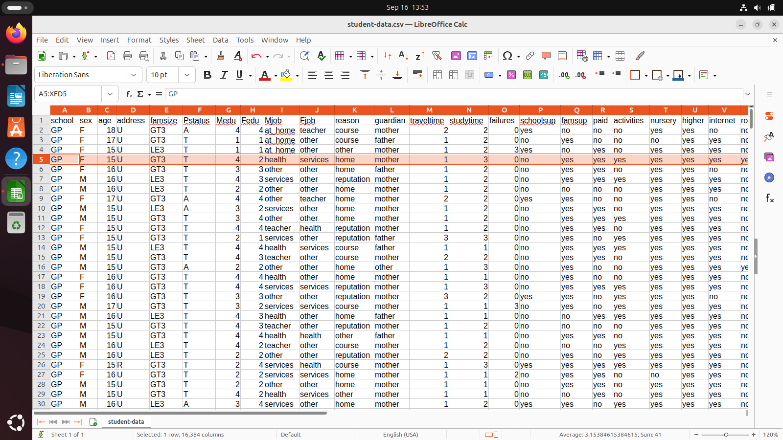

Figure - Delete from middle

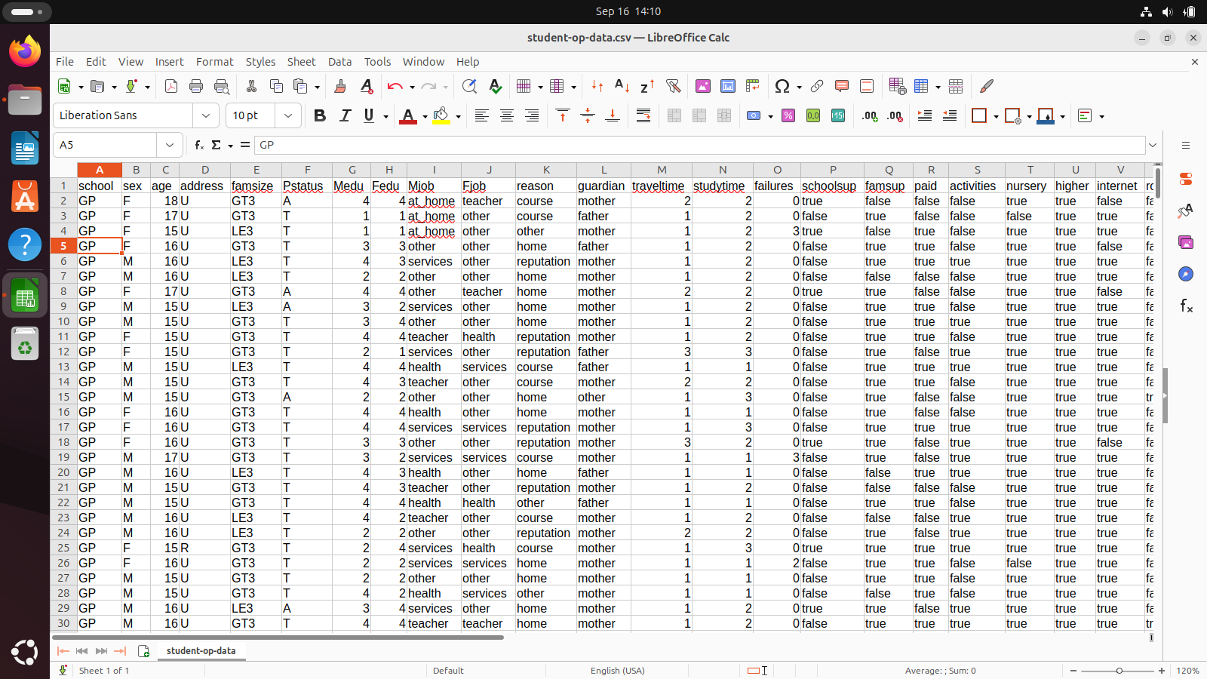

Figure -Output reflection deletion from middle

### 5.1.3 Insert at end

Insert a student record at the end of the existing CSV as shown

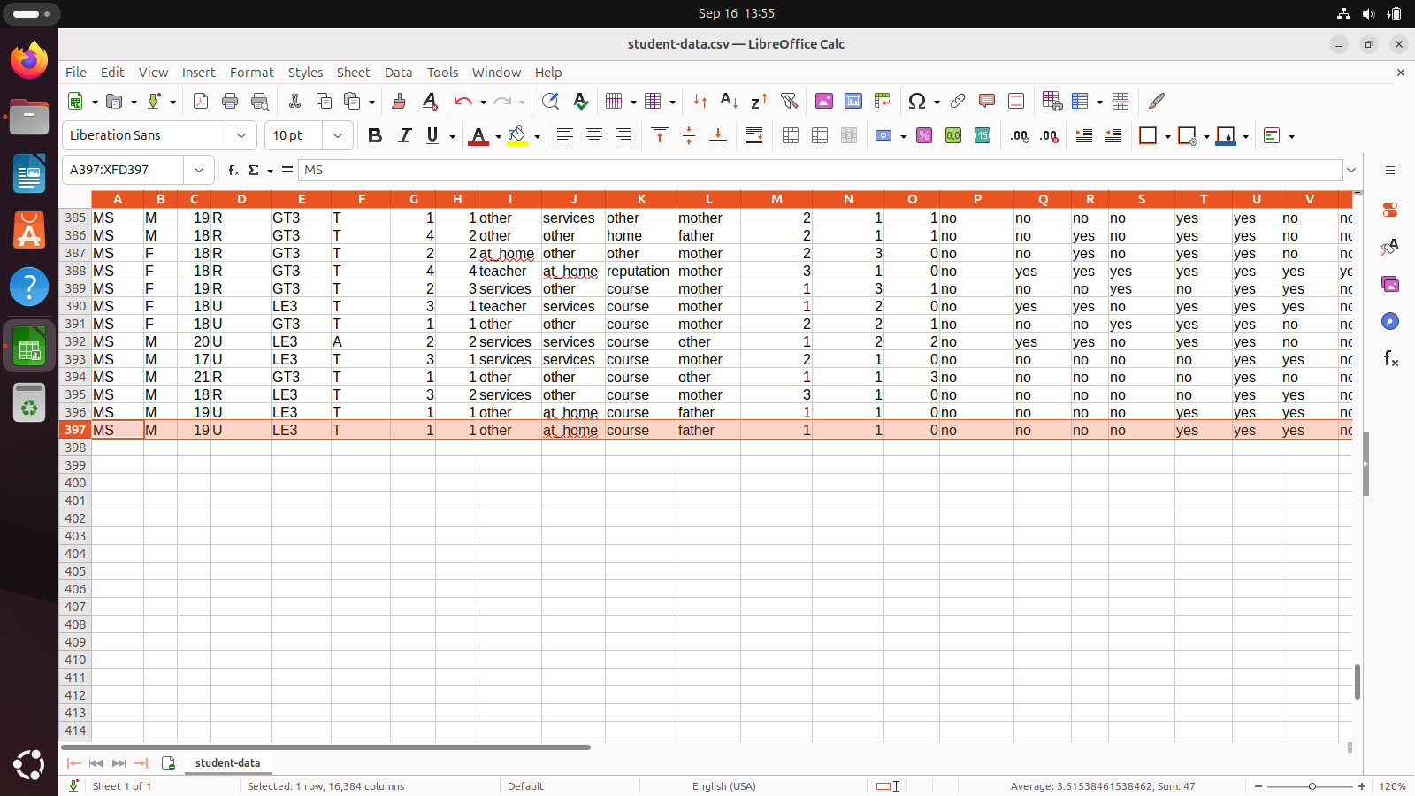

Figure - Insertion at the end

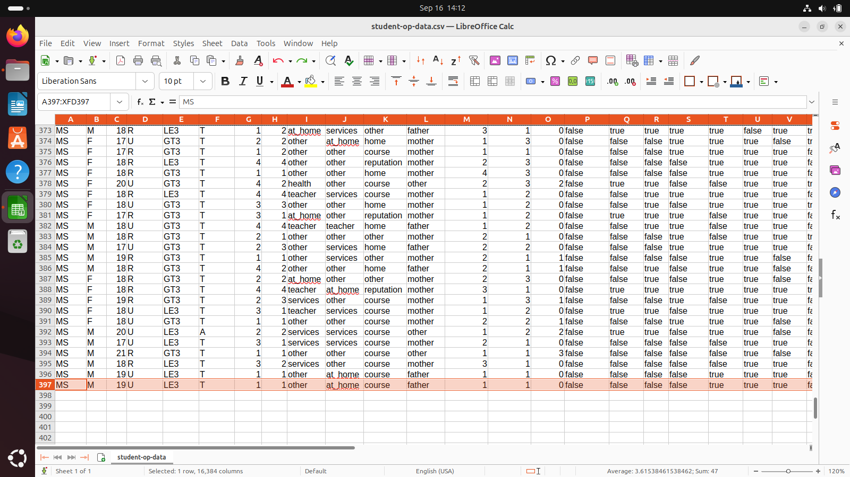

Figure - Output reflection insertion at the end

### 5.1.4 Delete at top

Delete a student record at the top of the existing CSV as shown

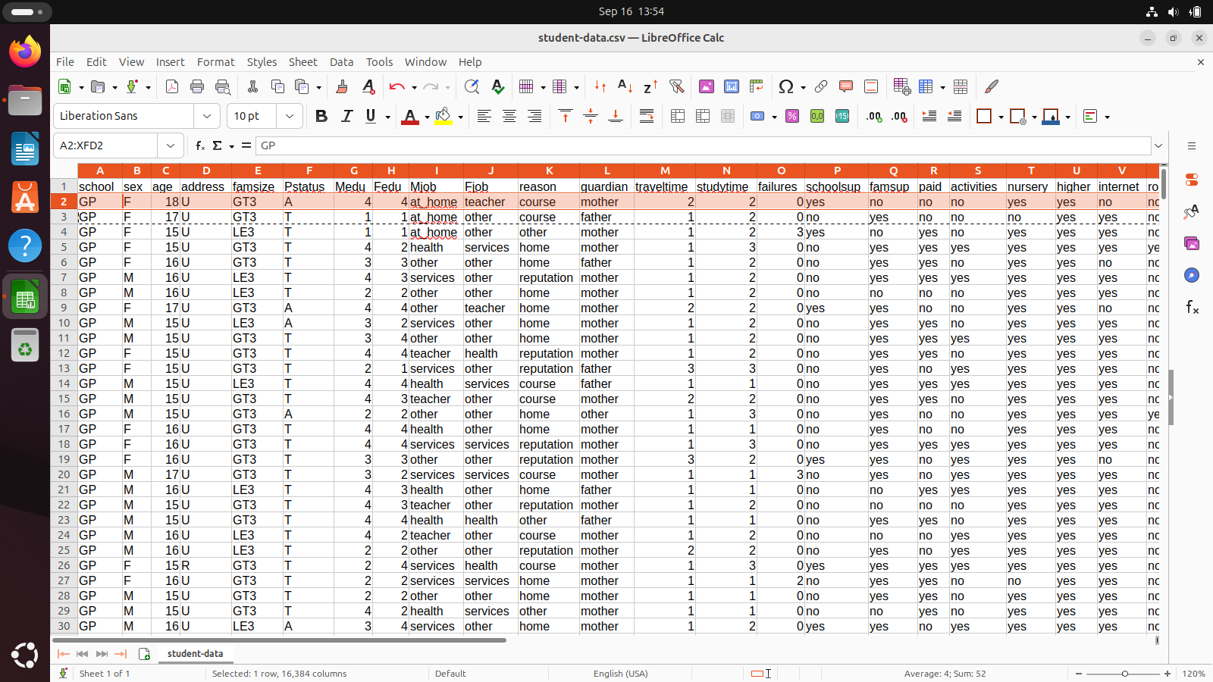

Figure - Delete the head

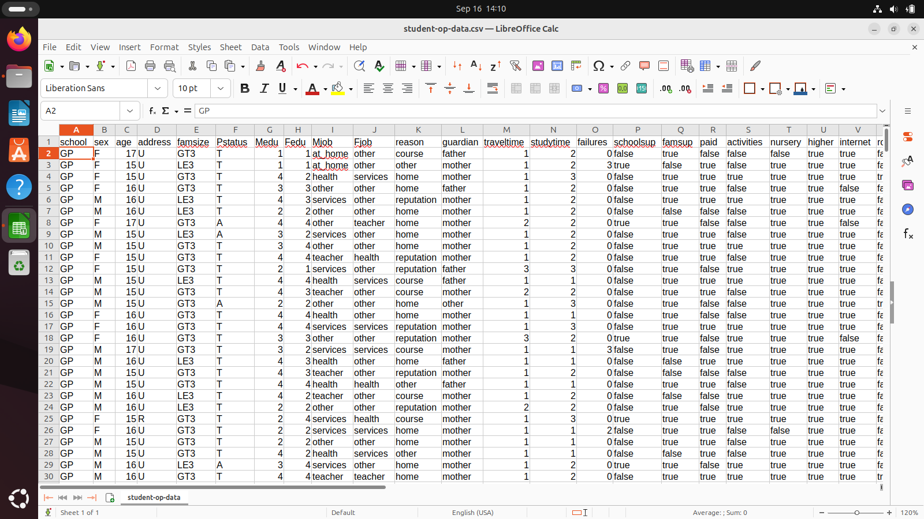

Figure - Output reflecting deletion of head

## 5.2 Edge cases

### 5.2.1 Insert at top

Insert a student record at the top of the existing CSV as shown

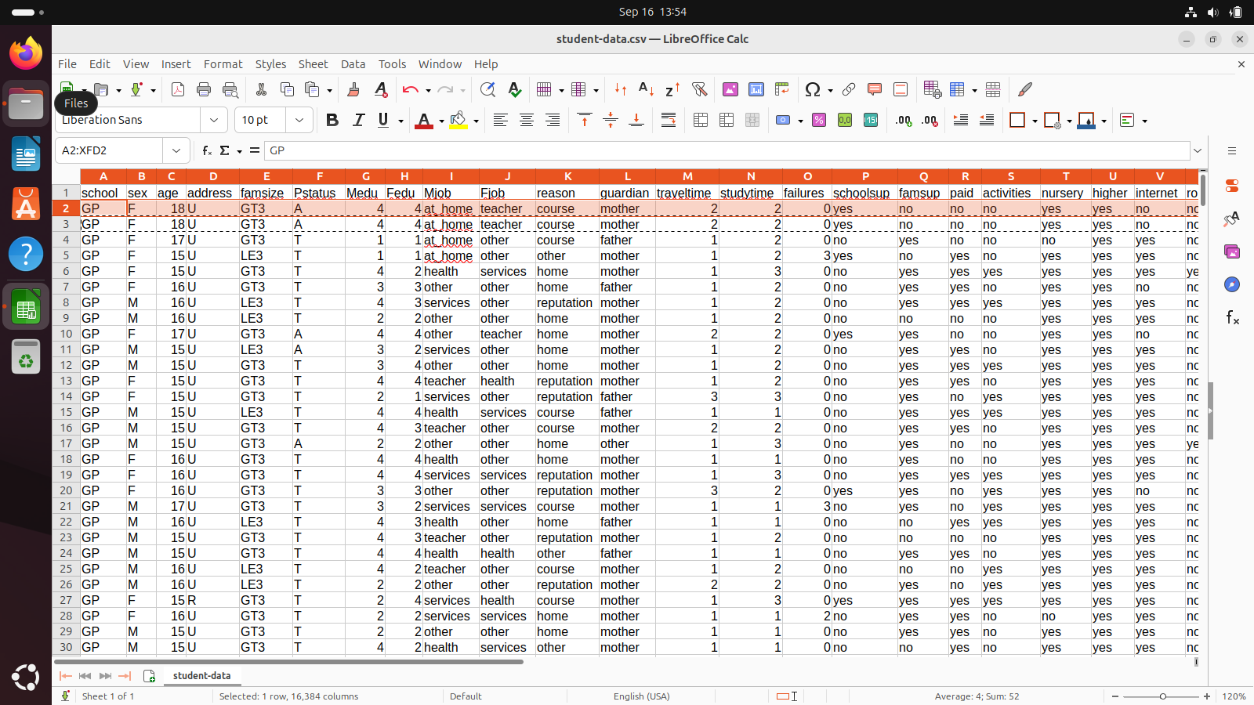

Figure - Insert a new head

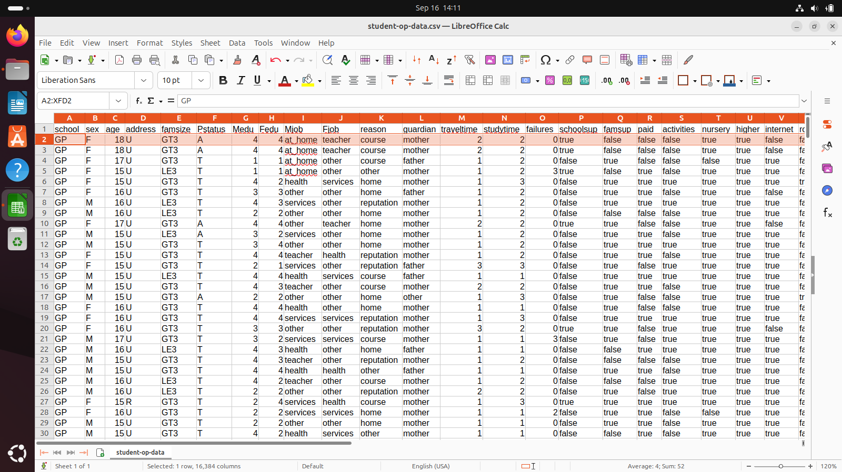

Figure - Output reflecting insertion of new head

### 5.2.2 Delete at end

Delete a student record at the bottom of the existing CSV as shown

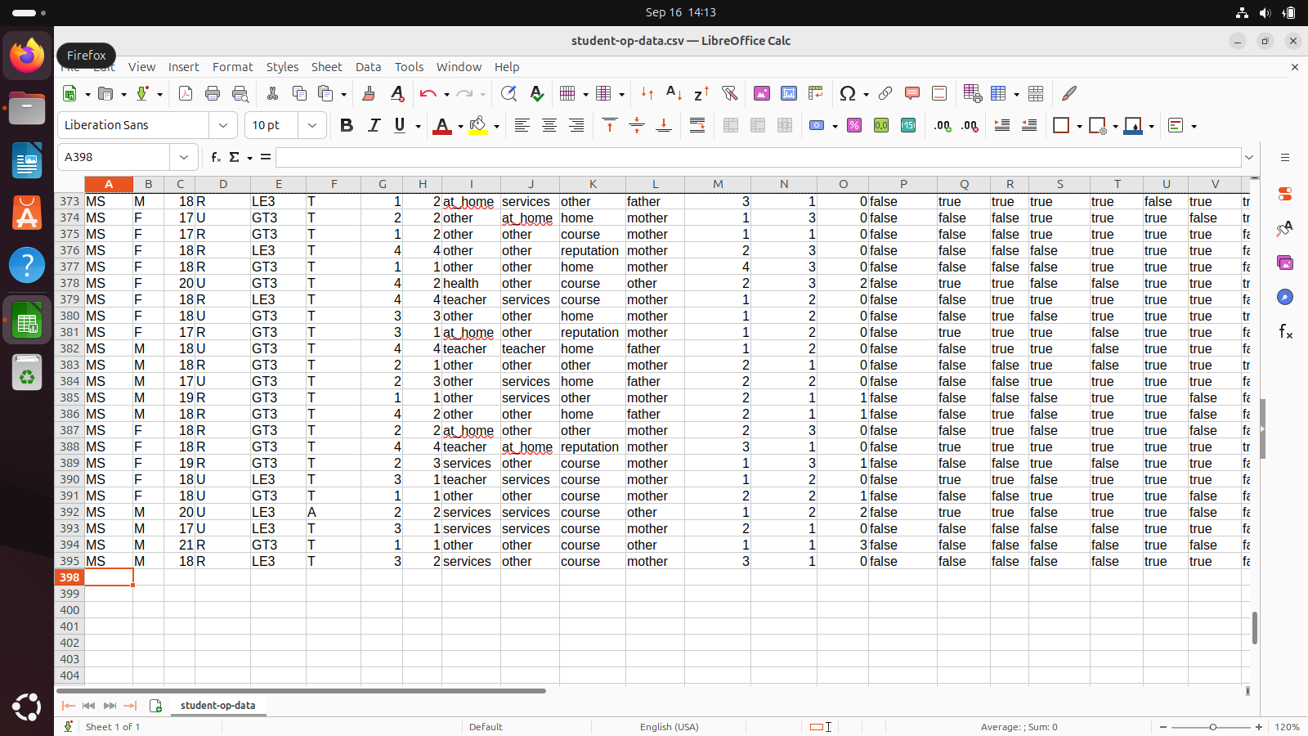

Figure - Delete the last node

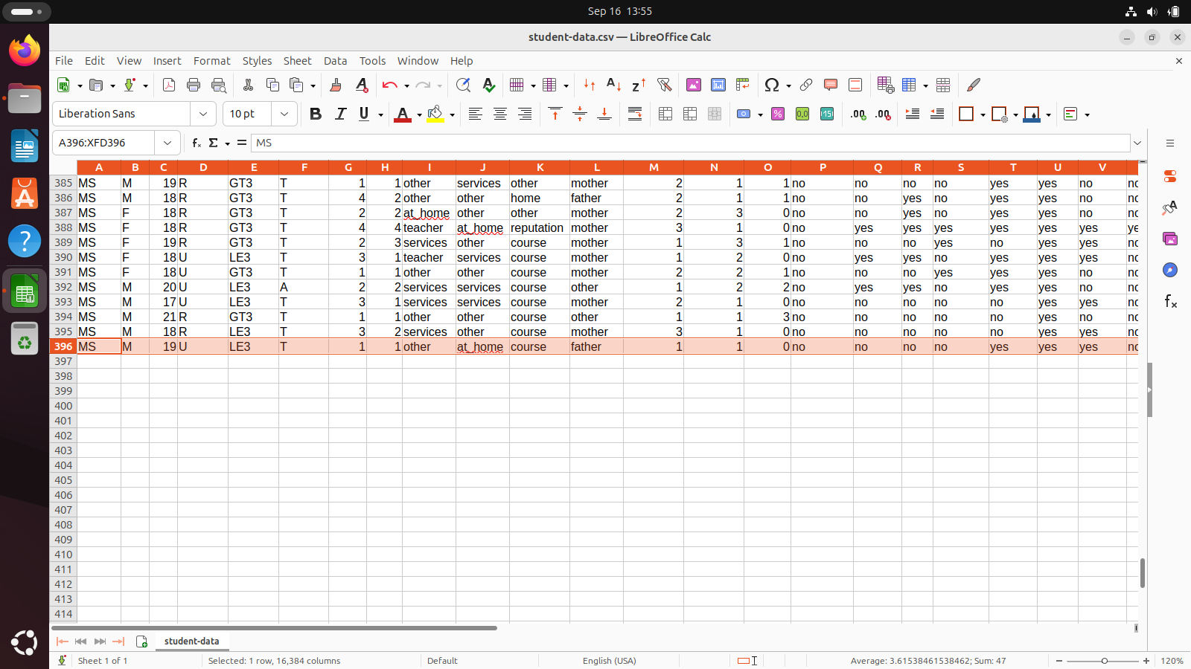

Figure - Output reflecting deletion of last node

### 5.2.3 No Insertion or deletion

It is not specified is the requirement document that there will always be insertions or deletion

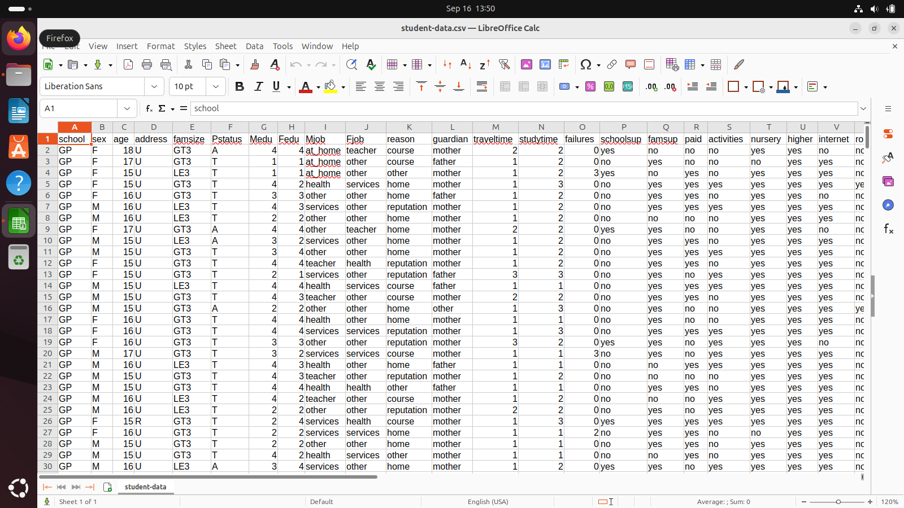

Figure - Unchanged input

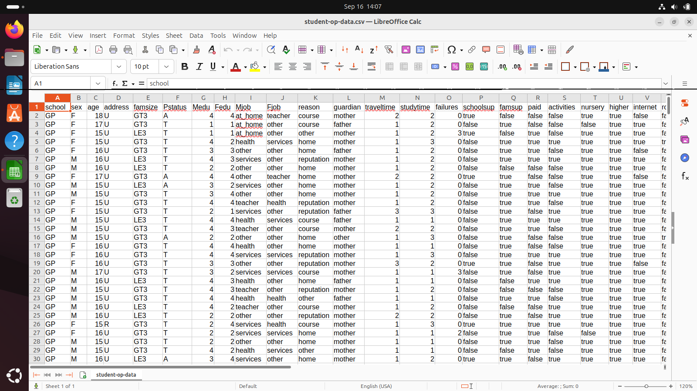

Figure - Unchanged output

# 5. Shutting down the Virtual environment

It is important to power off the Ubuntu virtual environment, as improper powering off might lead to the crashing of the OS.

1. Click on the battery icon in top right corner > click the power symbol > Power off… > confirm

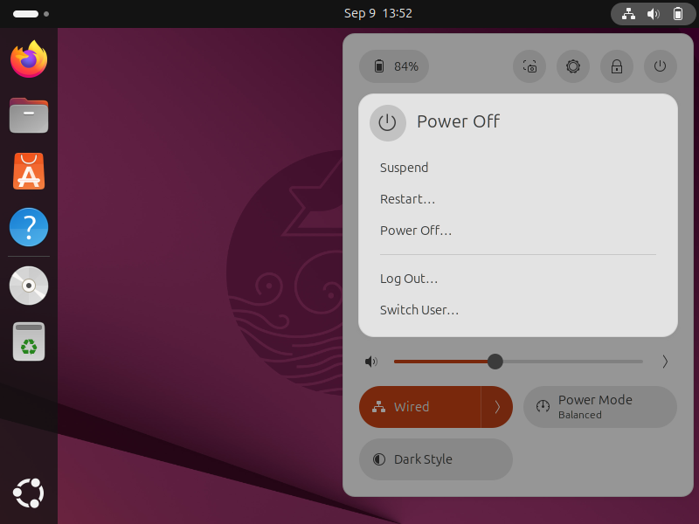

Figure - Shutting down Ubuntu

# Key takeaways

## Singly Linked List

It is a data structure; unlike arrays they offer **dynamic** **scaling**. They are made of interconnection blocks, the simple real-world parallel would be a **Train**, each block contain 2 parts one to have the **data** itself and the other to point to the location of the **next** block. By this way we can easily scale the number of block. Linked lists are the perfect choice when we need to allocate “n” data points, where **n is unknown**. They do have quite **a few tradeoffs** with array in terms of complexities both time and space.

## Recursion

Recursion is a type of loops, written when we don’t know the exit condition before hand. A safe comparison would be an **infinite** **loop** with a **break**; condition in it. Also we have normal and **tail recursions**.

## File IO

We have touched the basics of **reading** and **writing** in a CSV file. Also we have used **File Watcher** service which is good for noticing any action performed on the file like creation, deletion and modification, it returns if there is any event on the file which is per says the hint of **event driven programming paradigm**.

## Multi Threads

It is a special case of programming where we use different program threads to accomplish a task in the same time, in the algorithm world it can be loosely equated to divide and conquer.

# Conclusion

From the above execution screenshots is the confirmed to have build a small in-memory database using single linked list, that performs the actions,

1. Reads the contents of CSV file and add it to Linked List recursively
2. Adopts to any insertion/deletion in the CSV file
3. Writes the linked List to the output CSV file.

# FAQ

1. Why not store the contents of the CSV as a comma separated string in the Linked List?

It is advised to use the Object Oriented approach, as it is easier to access and extend in the future

1. Why not use String data type for all the class variables of the Student class?

String is not a primitive data structure and consumes a lot of memory space, Always use primitive data types like int char and Boolean when possible

1. Why dependency injection?

Dependency is a good software design practice, where it is easier to plug-in different initialization values

1. Is it ok to open both Reader and Writer object simultaneously, wont it cause synchronization problem

There won’t be any synchronizations issues due to opening two files concurrently, since we read and write into two different files, so there is no need to use any Mutex locks.

1. Why multi-threads

File watcher is a blocking service, even if we do an infinite loop until keyboard interrupt, the File watcher will still be blocking and won’t return the control to the main threads.

1. What is the difference between == and .equals() method in Java?

‘==’ does shallow comparison i.e. return two object points to the same memory location, can be used for comparing two primitive data type items on the other hand we .equals() method perform deep comparison i.e. it compares all the member variable of both the classes to say wheatear they are same, used when comparing two class variables. Note by default .equals() method does shallow comparison until overwritten manually.

1. What is the difference between write and append

Write operation overwrites the existing line and append operation goes to the new line to write a new line

1. What is static in Java

Object defined by static keywords gets initialized when the program starts by the JVM itself. For example main() method is defined static so it will be triggered by the JVM. We use static variables to define filenames and a static inner class. Unnecessary use of static keyword is not advised.

# Acknowledgement

I remember encountering a similar question in one of my interviews, confirming the relevance of the assignment to industry standards. I would like to acknowledge Professor Dr. **Wei “David” Dai**, for assigning this Assignment as it is a great practice for me. Also I would like to appreciate **PNW CES** and **CS** department for providing me the adequate opportunities and letting take this course.

Also I would like to thanks **Kaggle** dataset, which was a crucial part of this assignment also **draw.io** which was use to draw the UML diagram.

# Bibliography

baeldung. (2024, January 2024). *java-nio2-watchservice*. Retrieved September 14, 2025, from baeldung: https://www.baeldung.com/java-nio2-watchservice

devna... (2025, July 23). *how-to-detect-file-changes-using-python*. Retrieved September 14, 2025, from geeksforgeeks: https://www.geeksforgeeks.org/python/how-to-detect-file-changes-using-python/

Kartik. (2025, Septmber 08). *geeksforgeeks*. Retrieved September 13, 2025, from multithreading-in-java: https://www.geeksforgeeks.org/java/multithreading-in-java/

Kartik. (2025, January 02). *geeksforgeeks*. Retrieved Septmber 14, 2025, from multithreading-python: https://www.geeksforgeeks.org/python/multithreading-python-set-1/

kellygakii. (n.d.). *student-data-csv*. Retrieved Septmber 14, 2025, from kaggle: https://www.kaggle.com/datasets/kellygakii/student-data-csv

oracle. (n.d.). *WatchService*. Retrieved September 16, 2025, from oracle: https://docs.oracle.com/javase/8/docs/api/java/nio/file/WatchService.html

programiz. (n.d.). *Linked List*. Retrieved Septemeber 12, 2025, from programwiz: https://www.programiz.com/dsa/linked-list

Programmer, T. (2024, August 13). *How to install Ubuntu 24.04 LTS in VirtualBox 2024*. Retrieved September 03, 2025, from Youtube: https://www.youtube.com/watch?v=Hva8lsV2nTk

Python. (n.d.). *threading*. Retrieved Septmber 16, 2025, from python: https://docs.python.org/3/library/threading.html

*queue*. (n.d.). Retrieved Septemeber 04, 2025, from programiz: https://www.programiz.com/dsa/queue

*Stack*. (n.d.). Retrieved September 04, 2025, from programiz: https://www.programiz.com/dsa/stack

# Appendix

# Using Java

## Student Class

*/*  
 @author: Kowshick Srinivasan  
 * @version: 1.0  
 * @Assignment: Hw2  
 */*  
  
import java.util.Objects;  
  
public class Student {  
 String school;  
 String mJob;  
 String fJob;  
 String reason;  
 String guardian;  
 String famSize;  
  
 *//Can convert one letters to char instead of default string  
 //for efficient memory usage* char sex;  
 char address;  
 char pStatus;  
  
 *//Can convert Integers to int instead of default string  
 //for efficient memory usage* int age;  
 int famRel;  
 int freeTime;  
 int goOut;  
 int dalc;  
 int walc;  
 int health;  
 int absence;  
 int travelTime;  
 int studyTime;  
 int failures;  
 int medu;  
 int fedu;  
  
  
 *//Can convert yes/no to boolean instead of default string  
 //for efficient memory usage* boolean schoolsUp;  
 boolean farmsUp;  
 boolean paid;  
 boolean activities;  
 boolean nursery;  
 boolean higher;  
 boolean internet;  
 boolean romantic;  
 boolean passed;  
  
  
 *//Constructor to initialize the class variables* public Student(String school, char sex, int age, char address,  
 String famSize, char pStatus, int medu, int fedu,  
 String mJob, String fJob, String reason,  
 String guardian, int travelTime, int studyTime,  
 int failures, boolean schoolsUp, boolean farmsUp,  
 boolean paid, boolean activities, boolean nursery,  
 boolean higher, boolean internet, boolean romantic,  
 int famRel, int freeTime, int goOut, int dalc, int walc,  
 int health, int absence, boolean passed) {  
 this.school = school;  
 this.sex = sex;  
 this.age = age;  
 this.address = address;  
 this.famSize = famSize;  
 this.pStatus = pStatus;  
 this.medu = medu;  
 this.fedu = fedu;  
 this.mJob = mJob;  
 this.fJob = fJob;  
 this.reason = reason;  
 this.guardian = guardian;  
 this.travelTime = travelTime;  
 this.studyTime = studyTime;  
 this.failures = failures;  
 this.schoolsUp = schoolsUp;  
 this.farmsUp = farmsUp;  
 this.paid = paid;  
 this.activities = activities;  
 this.nursery = nursery;  
 this.higher = higher;  
 this.internet = internet;  
 this.romantic = romantic;  
 this.famRel = famRel;  
 this.freeTime = freeTime;  
 this.goOut = goOut;  
 this.dalc = dalc;  
 this.walc = walc;  
 this.health = health;  
 this.absence = absence;  
 this.passed = passed;  
 }  
  
 *//To String method to convert student object to comma separated Strings* @Override  
 public String toString() {  
 return school +  
 "," + sex +  
 "," + age +  
 "," + address +  
 "," + famSize +  
 "," + pStatus +  
 "," + medu +  
 "," + fedu +  
 "," + mJob +  
 "," + fJob +  
 "," + reason +  
 "," + guardian +  
 "," + travelTime +  
 "," + studyTime +  
 "," + failures +  
 "," + convertBoolToString(schoolsUp) +  
 "," + convertBoolToString(farmsUp) +  
 "," + convertBoolToString(paid) +  
 "," + convertBoolToString(activities) +  
 "," + convertBoolToString(nursery) +  
 "," + convertBoolToString(higher) +  
 "," + convertBoolToString(internet) +  
 "," + convertBoolToString(romantic) +  
 "," + famRel +  
 "," + freeTime +  
 "," + goOut +  
 "," + dalc +  
 "," + walc +  
 "," + health +  
 "," + absence +  
 "," + convertBoolToString(passed);  
 }

*//Convert the boolean object back to user specified String*private String convertBoolToString(boolean studentVariable) {  
 return studentVariable?"yes":"no"; *//If bool is True convert to yes else no*}

*//Equals method compare two object of same type (deep comparison) to tell if they are both equal* @Override  
 public boolean equals(Object obj) {  
 if (this == obj) return true; *//If both are the same object* if (!(obj instanceof Student student)) return false; *// If your comparing with some other object tye  
 //Convert the type of Object to Student* return Objects.*equals*(school, student.school) &&  
 Objects.*equals*(mJob, student.mJob) &&  
 Objects.*equals*(fJob, student.fJob) &&  
 Objects.*equals*(reason, student.reason) &&  
 Objects.*equals*(guardian, student.guardian) &&  
 Objects.*equals*(famSize, student.famSize) &&  
 Objects.*equals*(sex, student.sex) &&  
 Objects.*equals*(address, student.address) &&  
 Objects.*equals*(pStatus, student.pStatus) &&  
 Objects.*equals*(age, student.age) &&  
 Objects.*equals*(famRel, student.famRel) &&  
 Objects.*equals*(freeTime, student.freeTime) &&  
 Objects.*equals*(goOut, student.goOut) &&  
 Objects.*equals*(dalc, student.dalc) &&  
 Objects.*equals*(walc, student.walc) &&  
 Objects.*equals*(health, student.health) &&  
 Objects.*equals*(absence, student.absence) &&  
 Objects.*equals*(travelTime, student.travelTime) &&  
 Objects.*equals*(studyTime, student.studyTime) &&  
 Objects.*equals*(failures, student.failures) &&  
 Objects.*equals*(medu, student.medu) &&  
 Objects.*equals*(fedu, student.fedu) &&  
 Objects.*equals*(schoolsUp, student.schoolsUp) &&  
 Objects.*equals*(farmsUp, student.farmsUp) &&  
 Objects.*equals*(paid, student.paid) &&  
 Objects.*equals*(activities, student.activities) &&  
 Objects.*equals*(nursery, student.nursery) &&  
 Objects.*equals*(higher, student.higher) &&  
 Objects.*equals*(internet, student.internet) &&  
 Objects.*equals*(romantic, student.romantic) &&  
 Objects.*equals*(passed, student.passed);  
  
 }  
}

## Linked List Class

*/*  
 @author: Kowshick Srinivasan  
 * @version: 1.0  
 * @Assignment: Hw2  
 */  
  
/**  
 * Class to define the structure of the linked list  
 */*public class LinkedList {  
 Node head; *//Contains object of type Node* public static class Node { *//static inner class to define the structure of node* Student student; *//Contains object of student* Node next; *//Contains an object of itself* Node(Student student) { *//Constructor to initialise* this.student = student;  
 next = null; *//the next node is null by default* }  
 }  
  
 */**  
 * @param prevItem The current last Node/pointer  
 * @param student The student object that needs to be inserted  
 * @param nextNode The following Node which needs to be pointed by the inserted node  
 * @return new last node  
 */* public Node insert(Node prevItem, Student student, Node nextNode) {  
 Node newStudent = new Node(student); *//Create the new student node* newStudent.next = nextNode;  
 if (prevItem == null)  
 this.head = newStudent; *//If linked list is empty, make the new student as the first/head node* else  
 prevItem.next = newStudent; *//Connect the previous node next to the new student node, extending the linked list chain* return newStudent;  
 }  
  
 */**  
 * The method is to delete the current node from the linked list.  
 *  
 * @param prevNode The current last Node/pointer  
 * @param nextNode The immediate next node after the current Node  
 */* public void delete(Node prevNode, Node nextNode) {  
 *//We can assign the next node pointer of the previous node to the next node instead of the current node.  
 // Since the current node is hanging in the heap space the garbage collector will remove it.* if (prevNode == null) head = nextNode; *//Delete at the head* else prevNode.next = nextNode;  
 }  
}

## MemoryDatabase class

import java.io.*;  
import java.nio.file.*;  
import java.util.Objects;  
import java.util.Scanner;  
*/*  
 @author: Kowshick Srinivasan  
 * @version: 1.0  
 * @Assignment: Hw2  
 */  
  
/**  
 * Memory database class that does:  
 * <p>  
 * a) load the student-data.csv file into the memory database through recursive function.  
 * <p>  
 * b) When a row is added or removed from the CSV file, the memory database will adapt to the changes.  
 * <p>  
 * c) export the memory database into a csv file through recursive function.  
 */*public class MemoryDatabase {  
  
 LinkedList list; *//Object of the linked list*

private static final String *BASEPATH* = "/home/kowshick/Downloads/AlgoIndHw2-main/IndHw2/Data"; *// target directory*

private static final String *FILENAME* = "student-data.csv"; *//input file name* private static final String *OUTFILE* = "student-op-data.csv"; *//output file name* LinkedList.Node prevNode;  
  
 Scanner sc; *//Scanner object* private static boolean *running* = true; *//Condition variable  
  
 //Constructor based dependency injection* public MemoryDatabase(LinkedList list, Scanner sc, LinkedList.Node prevNode) {  
 this.list = list;  
 this.sc = sc;  
 this.prevNode = prevNode;  
 }  
  
 public static void main(String[] args) {  
  
 Scanner scanner = new Scanner(System.*in*);  
 MemoryDatabase database = new MemoryDatabase(  
 new LinkedList() *//Initialize the list object* , new Scanner(System.*in*), null); *//Initialize the scanner object*File inputFile = new File(*BASEPATH*,*FILENAME*);  
File outputFile = new File(*BASEPATH*,*OUTFILE*);

*//Since we used try with resources, we won't be needing a finally block* try (BufferedReader br = new BufferedReader(new FileReader(inputFile)); *//Buffered reader to enable to the Java methods to read from the given file* PrintWriter printWriter = new PrintWriter(new FileWriter(outputFile))) *//Buffered writer to enable the Java methods to write on the given file* {  
 String header = br.readLine(); *//read the Header of the csv* database.read(br, database.list.head); *//Read the student details from the file and add it to the linked list* System.*out*.println("Press 0 to exit"); *//KeyBoard interrupt to signal make watcher thread to stop and join back to the main* Thread watcherThread = new Thread(() -> { *//Load the watcher method to the watcherThread* try {  
 database.watcher();  
 } catch (Exception e) {  
 throw new RuntimeException(e);  
 }  
 });  
 watcherThread.start(); *//Start the watcher thread* while (true) {  
 if (scanner.hasNext() && Objects.*equals*(scanner.nextLine(), "0")) { *//If there is any keyboard input, and it is 0  
 running* = false; *//change the contention variable to false  
 //watcherThread.join(); //Resume after the completion of watcher thread* System.*out*.println("Stopping watcher..."); *//Stop the watcher service* break;  
*// }* }  
 }  
  
  
 printWriter.println(header); *//print the Header of the csv* database.print(database.list.head, printWriter); *//Method to print the traverse the Linked list and print in the csv* } catch (Exception e) { *//Global catch block to handle all the exception thrown by the program* e.printStackTrace(System.*out*); *//print the exception stack trace in console* }  
  
 }  
  
  
 */**  
 * Method recursively read each student details from the CSV file and adds it to the end of the linked list  
 *  
 * @param br : The BufferedReader object  
 * @param current : Current Node/pointer of the linked list  
 * @return : Completion status of the read operation  
 */* private int read(BufferedReader br, LinkedList.Node current) throws IOException {  
 String l = br.readLine(); *//Read each line* if (l == null) return 0; *//When reached EOF return* String[] line = l.split(","); *//Split the row using "," as the separator* Student student = convertLineToStudent(line); *//Convert the String array to the student class* return read(br, list.insert(current, student, null)); *//Recursively call the function with the buffered reader object and updated last Node/Pointer* }  
  
  
 */**  
 * Accepts the String array and convert it to student object  
 *  
 * @param line Original String array formed after comma separation of the line  
 * @return Student object  
 */* private Student convertLineToStudent(String[] line) {  
 return new Student(line[0], line[1].charAt(0), Integer.*parseInt*(line[2]), line[3].charAt(0), line[4], line[5].charAt(0),  
 Integer.*parseInt*(line[6]), Integer.*parseInt*(line[7]), line[8], line[9], line[10], line[11],  
 Integer.*parseInt*(line[12]), Integer.*parseInt*(line[13]), Integer.*parseInt*(line[14]), line[15].equals("yes"), line[16].equals("yes"), line[17].equals("yes"), line[18].equals("yes"), line[19].equals("yes"),  
 line[20].equals("yes"), line[21].equals("yes"), line[22].equals("yes"), Integer.*parseInt*(line[23]), Integer.*parseInt*(line[24]), Integer.*parseInt*(line[25]), Integer.*parseInt*(line[26]),  
 Integer.*parseInt*(line[27]), Integer.*parseInt*(line[28]), Integer.*parseInt*(line[29]), line[30].equals("yes"));  
  
 }  
  
  
 */**  
 * Recursively prints the student data to the csv file  
 *  
 * @param current : Accepts the current NOde/pointer of the Linked List  
 * @param printWriter : Accepts the Printed writer object  
 * @return : return the completion status of the printing action  
 */* private int print(LinkedList.Node current, PrintWriter printWriter) {  
 String row = current.student.toString(); *//Converts the student object to comma separated string* printWriter.println(row); *//Prints the string to the csv file* if (current.next == null) *//When reached end node return completion status* return 0;  
 return print(current.next, printWriter); *//recursively call the print method with updated last node pointer* }  
  
 */**  
 * Watches for any changes in the csv file  
 */* private void watcher() throws Exception {  
 WatchService watchService = FileSystems.*getDefault*().newWatchService(); *//create a watcher service* Path path = Paths.*get*(*BASEPATH*);path.register(watchService, StandardWatchEventKinds.*ENTRY_MODIFY*); *//Notify when there is a modification event* while (*running*) { *//run the loop until the condition variable is true* WatchKey key = watchService.take(); *// blocks until an event* for (WatchEvent<?> event : key.pollEvents()) {  
 WatchEvent.Kind<?> kind = event.kind();  
 Path changed = (Path) event.context();  
 if (changed.endsWith(*FILENAME*) && kind == StandardWatchEventKinds.*ENTRY_MODIFY*) {  
 System.*out*.println("student-data.csv has changed!"); *//Notify there is a change detected in the file* BufferedReader br = new BufferedReader(new FileReader(*FILENAME*)); *//buffered reader object of the file* br.readLine(); *//skip the header* reload(list.head, br); *//Reload only the changes* }  
  
 }  
 boolean valid = key.reset();  
 if (!valid) break;  
 }  
 }  
  
  
 private int reload(LinkedList.Node current, BufferedReader br) throws IOException {  
 String row = br.readLine();  
 if (current.next != null && row != null) { *//When both the linked list and file is not at the end,  
 // i.e. insertion/deletion happens at head in the middle* String[] line = row.split(",");  
 Student newStudent = convertLineToStudent(line);  
 *//Change detected* if (!newStudent.equals(current.student)) { *//There is a change in the current node and the file row, investigate further* LinkedList.Node nextNode = current.next;  
 if (nextNode.next == null || nextNode.student.equals(newStudent)) { *//if the current node is the last or if the next node is same as the current row,  
 // then the current row has been deleted, so we need to delete current node* list.delete(prevNode, nextNode); *//deletion operation* } else  
 list.insert(prevNode, newStudent, nextNode); *//Insertion operation* }  
 prevNode = current; *//Store the current node* return reload(current.next, br); *//recursively call with the next node and reader object* } else if (current.next == null && row != null) { *//If the linked list has reached its end but not the file,  
 // then there is something to be inserted at the end of the Linked list* String[] line = row.split(",");  
 Student newStudent = convertLineToStudent(line);  
 LinkedList.Node newNode = list.insert(prevNode, newStudent, null);  
 prevNode = newNode; *//Store the current node* return reload(newNode, br); *//recursively call with the next node and reader object* } else if (current.next != null) { *//If the File has reached its end and not the Linked List,  
 // there is something to be deleted from the end of the LinkedList* list.delete(prevNode, null); *//delete all the Node that are excess than the File  
 //No need to recursively call since we need to delete everything that are excess* }  
 return 0; *//both File and Linked list has reached the end* }  
}

# 2.Using Python

## 2.1Student Class

*#@author Kowshick Srinivasan  
#@version: 1.0  
#@Assignment: Hw2*

class Student:  
 def __init__(self, school,  
 sex,  
 age,  
 address,  
 fam_size,  
 p_status,  
 medu,  
 fedu,  
 m_job,  
 f_job,  
 reason,  
 guardian,  
 travel_time,  
 study_time,  
 failures,  
 schools_up,  
 farms_up,  
 paid,  
 activities,  
 nursery,  
 higher,  
 internet,  
 romantic,  
 fam_rel,  
 free_time,  
 go_out,  
 dalc,  
 walc,  
 health,  
 absence,  
 passed):  
 self.school = school  
 self.sex = sex  
 self.age = age  
 self.address = address  
 self.fam_size = fam_size  
 self.p_status = p_status  
 self.medu = medu  
 self.fedu = fedu  
 self.m_job = m_job  
 self.f_job = f_job  
 self.reason = reason  
 self.guardian = guardian  
 self.travel_time = travel_time  
 self.study_time = study_time  
 self.failures = failures  
 self.schools_up = schools_up  
 self.farms_up = farms_up  
 self.paid = paid  
 self.activities = activities  
 self.nursery = nursery  
 self.higher = higher  
 self.internet = internet  
 self.romantic = romantic  
 self.fam_rel = fam_rel  
 self.free_time = free_time  
 self.go_out = go_out  
 self.dalc = dalc  
 self.walc = walc  
 self.health = health  
 self.absence = absence  
 self.passed = passed  
  
 def __str__(self):  
 return [self.school, self.sex, self.age, self.address, self.fam_size, self.p_status, self.medu, self.fedu,  
 self.m_job, self.f_job, self.reason, self.guardian, self.travel_time, self.study_time, self.failures,  
 self.convert_bool_to_string(self.schools_up), self.convert_bool_to_string(self.farms_up), self.convert_bool_to_string(self.paid),  
 self.convert_bool_to_string(self.activities), self.convert_bool_to_string(self.nursery), self.convert_bool_to_string(self.higher),  
 self.convert_bool_to_string(self.internet),self.convert_bool_to_string(self.romantic), self.fam_rel, self.free_time, self.go_out,  
 self.dalc, self.walc, self.health, self.absence,self.convert_bool_to_string(self.passed)]

def __eq__(self, obj):  
 if not isinstance(obj, Student):  
 return False  
 return (self.school == obj.school and  
 self.sex == obj.sex and  
 self.age == obj.age and  
 self.address == obj.address and  
 self.fam_size == obj.fam_size and  
 self.p_status == obj.p_status and  
 self.medu == obj.medu and  
 self.fedu == obj.fedu and  
 self.m_job == obj.m_job and  
 self.f_job == obj.f_job and  
 self.reason == obj.reason and  
 self.guardian == obj.guardian and  
 self.travel_time == obj.travel_time and  
 self.study_time == obj.study_time and  
 self.failures == obj.failures and  
 self.schools_up == obj.schools_up and  
 self.farms_up == obj.farms_up and  
 self.paid == obj.paid and  
 self.activities == obj.activities and  
 self.nursery == obj.nursery and  
 self.internet == obj.internet and  
 self.higher == obj.higher and  
 self.romantic == obj.romantic and  
 self.fam_rel == obj.fam_rel and  
 self.free_time == obj.free_time and  
 self.go_out == obj.go_out and  
 self.dalc == obj.dalc and  
 self.walc == obj.walc and  
 self.health == obj.health and  
 self.absence == obj.absence and  
 self.passed == obj.passed)

def convert_bool_to_string(self, boolean_variable):  
 if boolean_variable:  
 return "yes"  
 else:  
 return "no"

## 2.2 Linked List Class

*#@author Kowshick Srinivasan  
#@version: 1.0  
#@Assignment: Hw2*

class Node: *#class to define the structure of node* def __init__(self, student):  
 self.student = student *#Contains object of student* self.next = None *#Contains an object of itself,the next node is null by default*class LinkedList:  
 def __init__(self):  
 self.head = None *#Contains object of type Node* def insert(self, current_node, student, next_node):  
 *"""  
  
 :param current_node: The current last Node/pointer  
 :param student: The student object that needs to be inserted  
 :param next_node: The following Node which needs to be pointed by the inserted node  
 :return: new last node  
 """* new_student = Node(student) *#Create the new student node* new_student.next = next_node  
 if current_node is None:  
 self.head = new_student *#If linked list is empty, make the new student as the first/head node* else:  
 current_node.next = new_student *#Connect the previous node next to the new student node, extending the linked list chain* return new_student  
  
 def delete(self, prev_node, next_node):  
 *"""  
 The method is to delete the current node from the linked list.  
 :param prev_node: The current last Node/ pointer  
 :param next_node: The immediate next node after the current Node  
 """  
 # We can assign the next node pointer of the previous node to the next node instead of the current node.  
 # Since the current node is hanging in the heap space the garbage collector will remove it.* if prev_node is None:  
  
 self.head = next_node *# Delete at the head* else:  
 prev_node.next = next_node

## 2.3 MemoryDatabase class

*#@author Kowshick Srinivasan  
#@version: 1.0  
#@Assignment: Hw2*

import csv  
import os  
import threading  
  
from LinkedList import LinkedList  
from Student import Student  
  
  
def convert_bool(param):  
 if param == "yes":  
 return True  
 else:  
 return False  
  
  
def convert_to_student(row):  
 line = list(row)  
 return Student(line[0], line[1], int(line[2]), line[3], line[4], line[5],  
 int(line[6]), int(line[7]), line[8], line[9], line[10], line[11],  
 int(line[12]), int(line[13]), int(line[14]), convert_bool(line[15]), convert_bool(line[16]),  
 convert_bool(line[17]), convert_bool(line[18]), convert_bool(line[19]),  
 convert_bool(line[20]), convert_bool(line[21]), convert_bool(line[22]), int(line[23]), int(line[24]),  
 int(line[25]), int(line[26]),  
 int(line[27]), int(line[28]), int(line[29]), convert_bool(line[30]))  
  
  
*# Memory database class that does:  
# a) load the student-data. csv file into the memory database through recursive function.  
# b) When a row is added or removed from the CSV file, the memory database will adapt to the changes.  
# c) export the memory database into a csv file through recursive function.*class MemoryDatabase:  
 BASEPATH = r"/home/kowshick/Downloads/AlgoIndHw2-main/IndHw2/Data"  
 FILENAME = os.path.join(BASEPATH, 'student-data.csv')  
 OUTFILE = os.path.join(BASEPATH, 'student-op-data.csv')  
  
 def read(self, current_node, input_csv):  
 *"""  
 Recursive method to read the CSV file and add the contends to the back of the Linked list  
 :param current_node: The current Node  
 :param input_csv: Reader object  
 :return: Completion status of the read operation  
 """* row = next(input_csv, None)  
 if row is None:  
 return 0  
 student = convert_to_student(row)  
 return self.read(self.list.insert(current_node, student, None), input_csv)  
  
 *# Constructor based dependency injection* def __init__(self):  
 self.list = LinkedList()  
 self.running = True  
 self.prev_node = None  
  
 def run(self):  
 with open(self.FILENAME, newline="") as inputFile:  
 input_csv = csv.reader(inputFile)  
 header = next(input_csv, None) *# read the Header of the csv* self.read(self.list.head, input_csv) *# Read the student details from the file and add it to the linked list* print('enter 0 to stop watching') *# KeyBoard interrupt to signal make watcher thread to stop and join back to the main* watcher_thread = threading.Thread(target=self.file_watcher) *# Load the watcher method to the watcherThread* watcher_thread.start() *# Start the watcher thread* if input() == '0': *# Blocking-instruction, makes the main thread to wait until there is user input 0* self.running = False *# Signal the watcher thread to stop* watcher_thread.join() *# Resume after the completion of watcher thread* with open(self.OUTFILE, mode='w', newline="") as outputFile:  
 output_csv_writer = csv.writer(outputFile)  
 output_csv_writer.writerow(header) *# print the Header of the csv* self.printer(self.list.head,  
 output_csv_writer) *# Method to print the traverse the Linked list and print in the csv* def printer(self, current, output_csv_writer):  
 *"""  
 Recursively prints the student data to the csv file  
 :param current: Accepts the current NOde/ pointer of the Linked List  
 :param output_csv_writer: Accepts the Printer writer object  
 :return: completion status of the printing action  
 """* row = current.student.__str__()  
 output_csv_writer.writerow(row)  
 if current.next is None:  
 return 0  
 return self.printer(current.next, output_csv_writer)  
  
 *# Watches for any changes in the csv file* def file_watcher(self):  
 last_modified = None  
 if os.path.exists(self.FILENAME):  
 last_modified = os.path.getmtime(self.FILENAME)  
 while self.running: *# run the loop until the condition variable is true* if os.path.exists(self.FILENAME):  
 current_modified = os.path.getmtime(self.FILENAME)  
 if last_modified is None or current_modified != last_modified:  
 print("changes detected in file")  
 with open(self.FILENAME, mode='r', newline='') as modified_file:  
 modified_csv = csv.reader(modified_file)  
 next(modified_csv, None) *# skip header* self.reload(self.list.head, modified_csv) *# Reload only the changes* last_modified = current_modified  
  
 def reload(self, current_node, input_csv):  
 row = next(input_csv, None)  
 *# When both the linked list and file is not at the end,  
 # i.e. insertion/deletion happens at head in the middle* if current_node.next is not None and row is not None:  
 new_student = convert_to_student(row)  
 *# There is a change in the current node and the file row, investigate further* if not new_student.__eq__(current_node.student): *#######problem* next_node = current_node.next  
 *# if the current node is the last or if the next node is same as the current row,  
 # then the current row has been deleted, so we need to delete current node* if next_node.next is None or next_node.student.__eq__(new_student):  
 self.list.delete(self.prev_node, next_node) *# deletion operation* else:  
 self.list.insert(self.prev_node, new_student, next_node) *# Insertion operation* self.prev_node = current_node *# Store the current node* return self.reload(current_node.next, input_csv) *# recursively call with the next node and reader object  
 # If the linked list has reached its end but not the file,  
 # then there is something to be inserted at the end of the Linked list* elif current_node.next is None and row is not None:  
 new_student = convert_to_student(row)  
 new_node = self.list.insert(self.prev_node, new_student, None)  
 self.prev_node = new_node *# Store the current node* return self.reload(new_node, input_csv) *# recursively call with the next node and reader object  
 # If the File has reached its end and not the Linked List,  
 # there is something to be deleted from the end of the LinkedList* elif current_node.next is not None:  
 self.list.delete(self.prev_node, None)  
 *# No need to recursively call since we need to delete everything that are excess* return 0 *# both File and Linked list has reached the end*if __name__ == '__main__':  
 db = MemoryDatabase()  
 db.run()

The above source code can also found in <https://github.com/kowshick20/AlgoIndHw2.git>

The source code can also be found in the onlineGDB

1. JAVA: <https://onlinegdb.com/CdqiP8PKl>
2. Python: <https://onlinegdb.com/9X9gvdQdy>